Lab 6 Report

Objectives:

• PCB Layout

• Systems level approach to embedded system design

- Mechanical considerations

- Available of parts (second source)

- Cost considerations

- Power considerations

• Design for Test

Project Selection:

The PCB design is based of the Lab 3 alarm clock that includes an LCD, speaker, and tactile switches.

Enclosure:

The SOD 6262-3.5 from Pactec is a square enclosure with interior dimensions of 5.97 x 5.97 x 3.54 inches. This is larger than my PCB footprint of 2.26 x 4.15 inches and will allow for additional components to be added such as a 5V Li-Poly battery and the HC-08 ble module.



Additional Component:

The additional component chosen to interface with the Lab 3 PCB design is the SH-HC-08 BLE module. The HC-08 module will allow for the project to add wireless control similar to Lab 4 with the ESP8266 but through low-energy Bluetooth communication. The module will communicate to the LaunchPad using UART attached to the PC6 and PC7 pins. This component will be powered using 5V and GND from the LiPoly battery and has the option of attaching the state/Interrupt request pin to the LaunchPad for added functionality using edge triggered interrupts for communication. All 5 pins (TX, RX, ST/IRQ, %V, GND) will be connected to the LaunchPad using a 5pin header on the PCB layout. Using a serial communication app on a smartphone, the HC-08 will allow the alarm clock to accept commands wirelessly to update the clock time, alarm settings, and view the status of the system. It also makes the system easier for the user to use so that they do not have to open the box, worry about adjusting the time too far or having to press the button dozens of times to get it set to the desired settings. They can simply follow the prompts the LaunchPad will send to the Serial screen on the app and input the desired values using a keyboard. It adds wireless capabilities and a better means to interface with the Lab 3 alarm clock. The component can be found on amazon for $7.99 from DSD Tech Industries. The schematic is attached below and the attaches to the 5pin HC-08 header on the PCB.

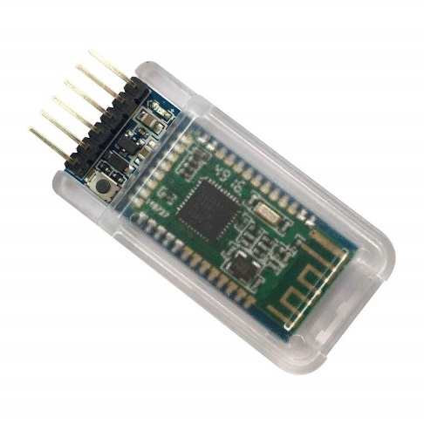[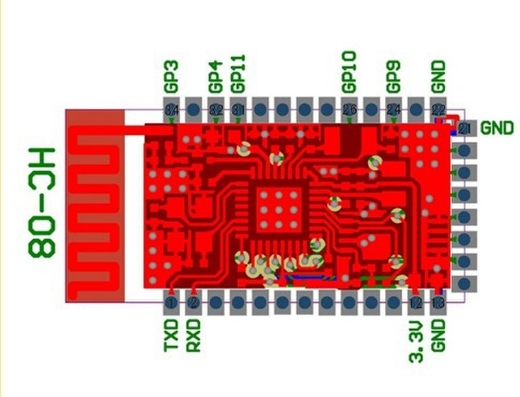](https://www.google.com/url?sa=i&rct=j&q=&esrc=s&source=images&cd=&cad=rja&uact=8&ved=2ahUKEwjjuJ2_iJTeAhUHZawKHSjeCaQQjRx6BAgBEAU&url=http%3A%2F%2Fwww.lxxtech.com%2Fhc-08-bluetooth-serial-module-bluetooth-40-microamp-current-long-range-low-power-bluetooth-p336.html&psig=AOvVaw3ExlXHzb87EWK8-qo8a2LI&ust=1540092130410696)

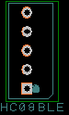

HC-08 Schematic

HC-08

HC-08 PCB 5pin Header component

Power Measurements:

Running the LCD requires approximately 71mA. With the speaker on the system draws approximately 83mA. The HC-08 will use approximately 115mA when in use and around 7mA in idle. Therefore, to run the alarm at worst case with constant wireless communication and the speaker on, the energy required is 198mA x 24hrs = 4752mAh. A 5000mAh Li-Poly battery would therefore be best to power this embedded system based on worst case power consumption.

Testing:

To ensure each PCB design works properly, I would flash each circuit with a simple code that runs through basic functions of the alarm clock triggering signal changes on the different pins connected to hardware such as the HC-08 TX and RX pins, or the transistor base pin. An oscilloscope would be attached to the test points printed on each PCB and a logic analyzer would be plugged into the header on the PCB to see the signal changes the code would trigger on PB GPIO pins. Using this method, I could verify that my code creates the desired output responses and can interpret incoming data, from the HC-08 for example, correctly.

Deliverables:

The SCH, PCB, Copper layouts, Silkscreen layouts, Bill of Materials, and PCB report files are attached separately along with this lab report.